Your reliable partner in reporting and document automation

Docentric Server Installation and Maintenance Guide

1. Hardware and Software Requirements 2
1.1. Hardware requirements 2
1.2. Software Requirements 2
2. Deployment 2
2.1. Deployment of the Web Service 2
2.1.1. Create the application folder with the required structure 2
2.1.2. Create a new user 3
2.1.3. Create a new Web Site 4
3. Applying Updates 7
4. Diagnostics 7
4.1. Error logging 7
4.2. Failed document generation dumps 7

Hardware and Software Requirements

Hardware requirements

Minimum and recommended hardware requirements
Processor, CPU cores | Intel Pentium/Celeron family or compatible Pentium III Xeon or higher processor. We recommend a processor speed of 2.0 GHz or faster.
RAM | Minimum: 2 GB  Recommended: 4 GB
HDD | Min 500 MB, recommended 1 GB (for logging purposes)

  - Software Requirements
- Windows Server 2012 R2 (min. Essentials edition)
- IIS Web Server 5.0 + (with ASP.NET and WCF enabled)
- .NET Framework 4.5

Deployment

Deployment of the Web Service

Create the application folder with the required structure
Copy all the files and folders necessary to a location on the production server that will be running the Docentric Server web service (e.g. C:\Inetpub\wwwroot\DocentricServer).
The structure looks like this:
- FOLDER App_Data
- FOLDER bin
  - FILE Docentric.Ax.Licensing.dll
  - FILE Docentric.Ax.WebService.dll
  - FILE Docentric.Documents.ObjectModel.dll
  - FILE Docentric.Documents.Reporting.dll
  - FILE Docentric.Drawing.dll
  - FILE Docentric.Pdf.dll
  - FILE Docentric.Shared.dll
  - FILE Docentric.OpenXml.dll
  - FILE Elmah.dll
- FILE Global.asax
- FILE Web.config
IMPORTANT: In order for the worker process be able to write log and trace files to disk, the account that the process runs under needs to have WRITE permissions for the App_Data folder. This can be done by adding the WRITE permission for IIS_IUSRS the user group for the App_Data folder.

Create a new user
In order to enable printing via Docentric Server, the service process needs to run under a user account. You need to create a dedicated user account instead of a built-in system account or IIS identity.
Consult your system administrator or create a new user account. You can follow steps in this tutorial https://technet.microsoft.com/en-us/library/cc732336(v=ws.11).aspx.
Note: Set the Password never expires checkbox to active (the User must change password at next logon option will be automatically unchecked).
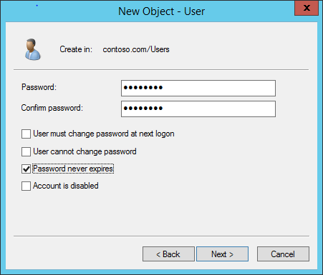

Add the created user account to the built-in group IIS_IUSRS.
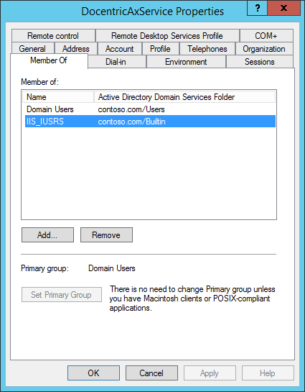

In the next step you will create a new web site. When finished you will set your newly created user (e.g. DocentricAxService) as Identity for the application pool of your newly created web site.

Create a new Web Site
Create a Web Site on the IIS Web Server. Set physical path pointing to the location where the application file structure resides. It is recommended that a dedicated Application Pool is created for this web site/application (a new application pool is created by default for a new web site automatically).
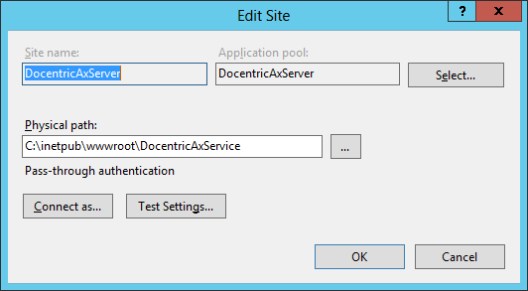
Application pool needs to be configured to run on .NET CLR version 4.0 and the value for Managed Pipeline needs to be set to Integrated.
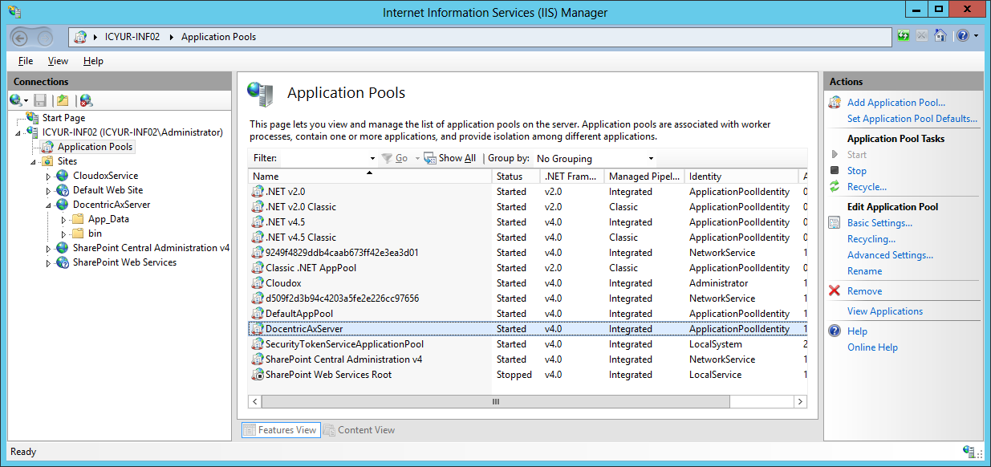

By default, a worker process running an application terminates after being idle for a period of time. A startup of a web application/service usually takes some time. In order to avoid the process being suspended for being idle, set the Idle Time-out setting to 0 (which means never).
Set the Identity property of the new application pool to previously created user account (e.g. the DocentricAxService account).
Also, check if the Load User Profile property is set to True (this is the default value). If this property is set to False, printing of the AX reports via Docentric Server will not work.

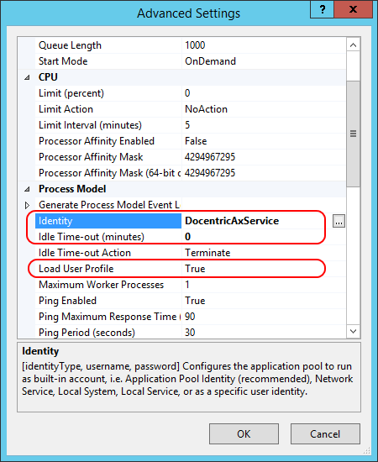

Applying Updates
In order to apply/deploy any fixes is as simple as copy-paste new version files over the old ones in the application folder (e.g. C:\Inetpub\wwwroot\DocentricServer) on the disk. There is no need to perform an additional action (restarting the web application or IIS server). The IIS web server will automatically restart the web service application.

Diagnostics
The web service implements Error Logging as well as Tracing.

Error logging
Error logging is implemented by using Elmah framework. Any unhandled exception that occurs during a service operation processing gets logged to the folder specified in the Elmah section in the Web.config file. In order to perform a clean-up, the files can always be deleted, including the folder itself (it gets automatically recreated).
The error logs can be accessed and viewed with the user interface that is integrated in the web service itself and can be accessed:
http://[Address]:[Port]/elmah.axd

Failed document generation dumps
The Docentric Server web application creates a folder inside the /App_Data/FailedDocumentGenerations folder containing several files each time an error occurs. The created files are the following:
- Template document used for the report/document generation.
- Docentric Data Source Package (.ddsp) file used for the report/document generation.
- Exception information including the exception message and the stack trace.

